Section 1: Hospital Information
Facility Name: Click or tap here to enter text. | Today’s Date: Click or tap to enter a date.
Surgeon Name: Last, First | Surgeon Email: Click or tap here to enter text.
 | Surgeon Phone: Click or tap here to enter text.
Section 2: Patient Information
Patient Name: Last, First
Date of Birth: Click or tap to enter a date. | Sex: ☐ Male ☐ Female
Section 3: Sales Representative Information
Name: Last, First
Company Name: Click or tap here to enter text.
Email: Click or tap here to enter text. | Telephone: Click or tap here to enter text.
Shipping Address: Sales Representative Address
Section 4: Case Information
Date of Surgery: Click or tap to enter a date. | PO #: Click or tap here to enter text.
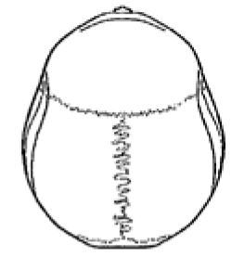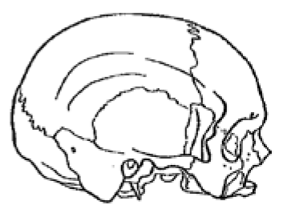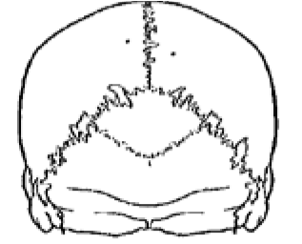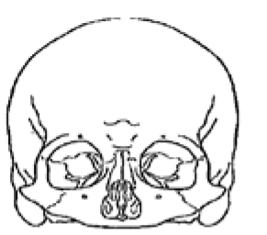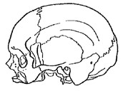
Indicate approximate location/outline of defect to be treated

Implant Design: (Check One. Default design options will be used unless otherwise specified):
☐ A. Customized Static Cranial Implant
☐ B. Single Stage Static Cranial Implant
Design Specifications (Complete if A is checked above)
Implant Fit: Click or tap here to enter text.
Additional Surgeon/Patient Need(s):
Click or tap here to enter text.

